<https://docs.microsoft.com/en-us/aspnet/core/web-api/action-return-types?view=aspnetcore-3.1>

<https://hamidmosalla.com/2017/03/29/asp-net-core-action-results-explained/>

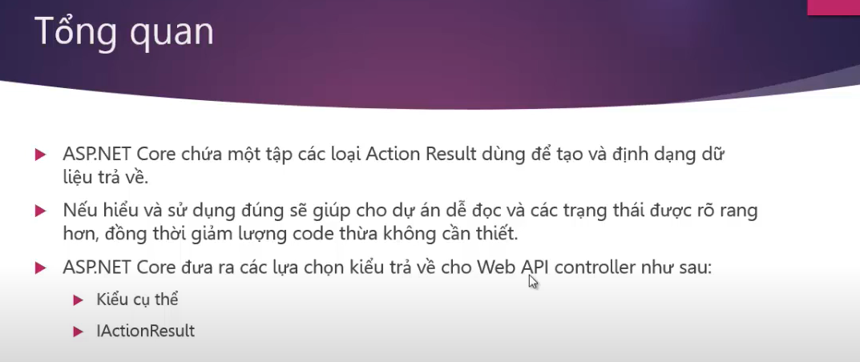

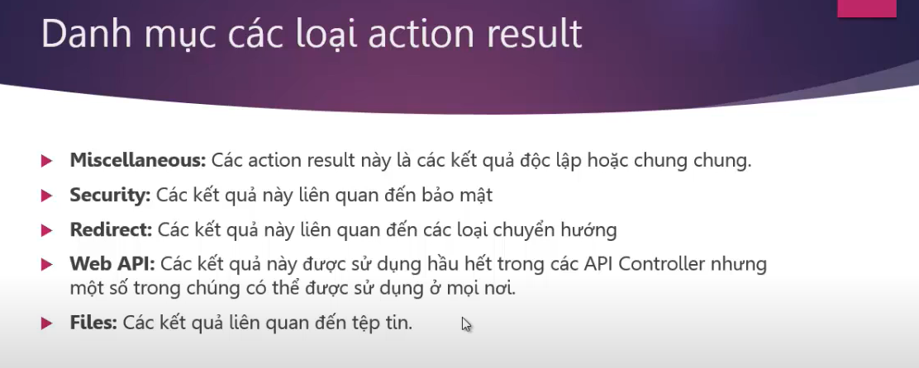

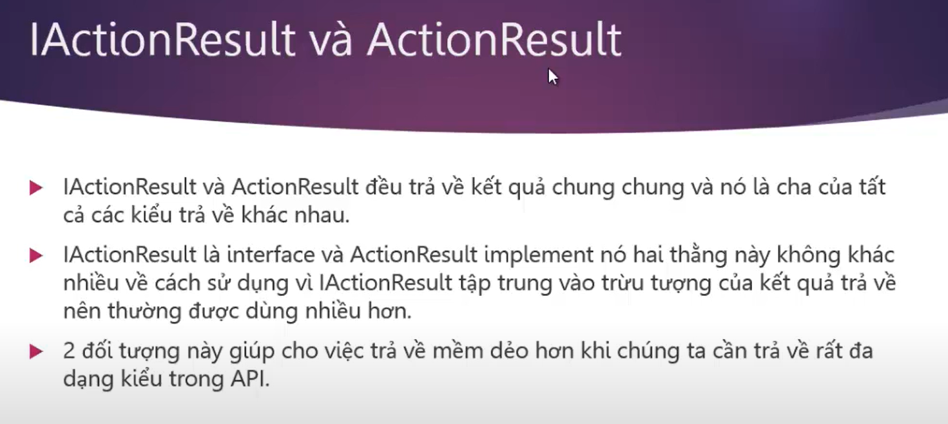

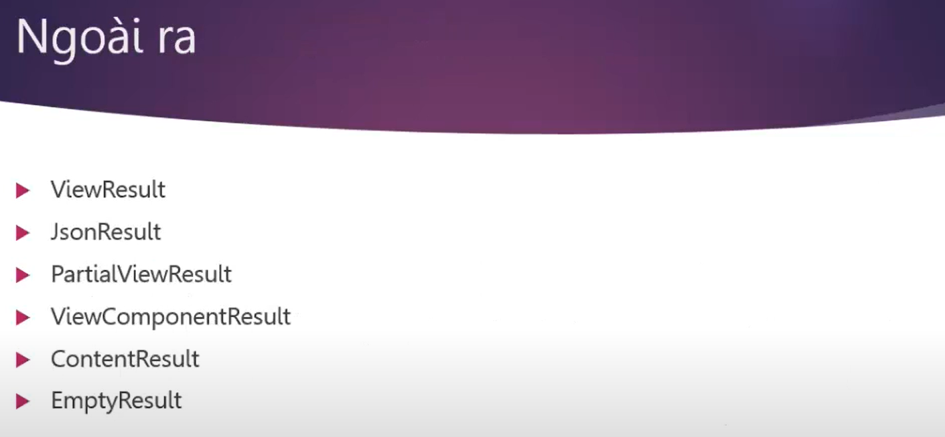

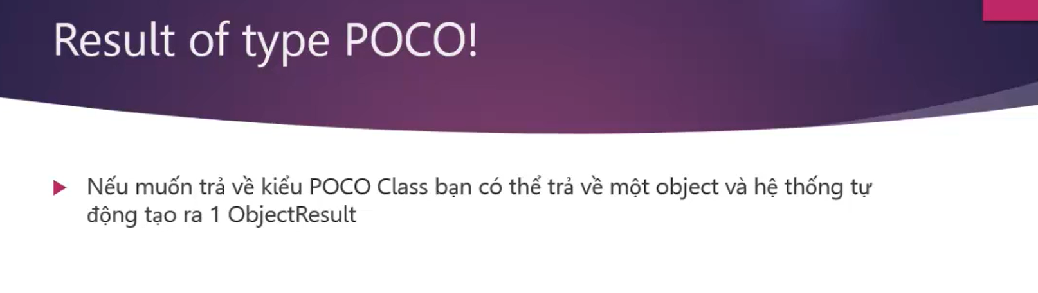

Ví dụ: Ok(result)

